
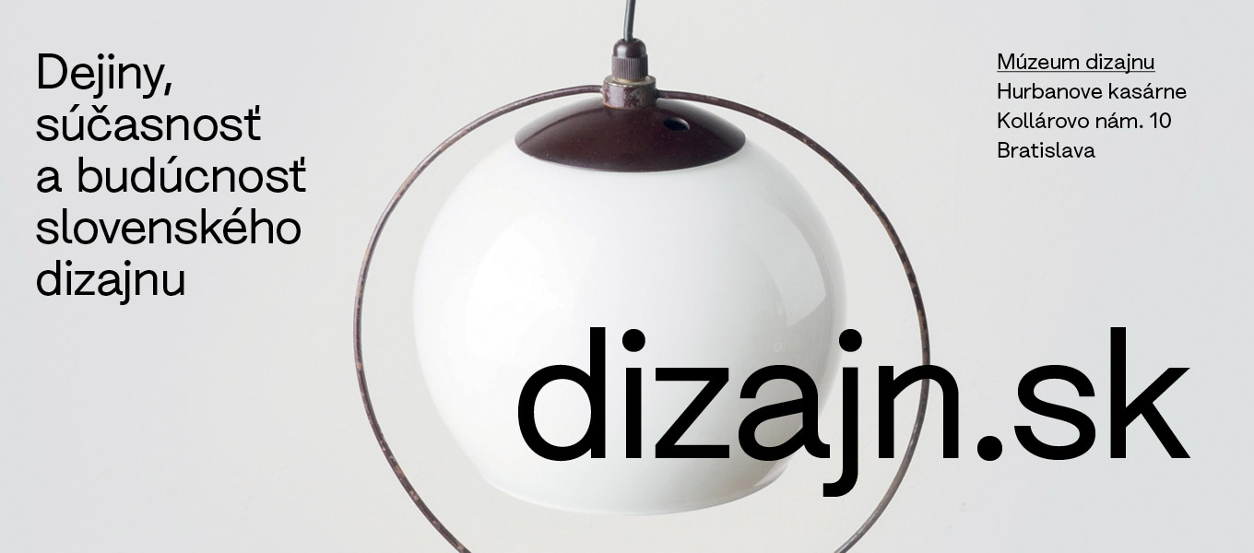

Slovak Design Center Slovak Design Museum
The Past, Present, and Future of Slovak Design
PRESS RELEASE
Bratislava, September 8, 2025

Location: Museum of Design, Hurbanove kasárne, Kollárovo nám. 10, Bratislava
Open: Tuesday – Sunday, 2:00 PM – 6:00 PM
Opening: September 17, 2025 at 6:00 PM
Guided tour: September 17, 2025 at 5:00 PM
Free admission

THE DESIGN MUSEUM OPENS ITS SECOND EXHIBITION OF SLOVAK DESIGN!
The dizajn.sk exhibition presents a curatorial selection of representative, timeless, and unique works of Slovak design of the 20th and 21st centuries from the collections of the Slovak Design Museum.
The basic motif of the exhibition consists of stories of Slovak design, told through individual works from various fields. They reveal fragments of the creative processes and ideas of designers unfolding against the backdrop of the times. The main feature of the exhibition is an exhibition system composed of an arrangement of upcycled lightboxes, which figuratively and literally illuminate iconic works of Slovak design.
The colorful history of design in Slovakia can still surprise with a forgotten prototype, a hand-crafted poster design or a drawing of a product that never made it into mass production. Contemporary Slovak design and applied art successfully present new paths to their own identity and at the same time reflect current social issues. They profile their future on technological innovations and the latest possibilities for experimenting with creative potential, shape, and material.
Mgr. art. Maroš Schmidt, director of the Slovak Design Center

Design is a living organism that is constantly changing, growing, and developing. A characteristic feature of the new exhibition at the Design Museum is the exhibition dynamics, thanks to which we can present the latest acquisitions and designs that resonate in the National Design Award or respond to the anniversaries of significant personalities of Slovak design.
For us, supporting design is an investment in cultural heritage and the creative future, which significantly shape society. Design is an everyday part of our lives – it affects how we live, how we work and how we feel. We believe that the dizajn.sk exhibition will be not only a glimpse into history for visitors, but also a source of inspiration, that Slovak design has the ability to create beauty and functionality in one.
Anna Macaláková, Director of J&T BANKA in Slovakia.
Design in Slovakia is made up of an endless number of “small” stories – ideas, experiments, various destinies of designers and manufacturers, but also of people who use, think about, and live with design. These stories also reflect “big” stories: the rhythm of the times, the voice of society, and the energy of the space in which they are created. "Our exhibition is an invitation to listen to and observe these stories - we believe that in this way the past and present of design will become part of other stories for the future.
Mgr. Silvia Seneši Lutherová, PhD., Deputy Director of the Slovak Design Center for Professional Affairs.

DESIGN CLUB
In cooperation with individual departments of the Slovak Design Center, the exhibits come to life in the exhibition and the Design Club through guided tours, discussions with designers, manufacturers, design theorists, and thematically rich accompanying events for both experts and the general public. Additional information and context of the exhibition are supplemented by professional magazines and publications in the Design Reading Room and the LOMA Materials Library. The exhibition also has an expanded form in the online space – on the website of the Slovak Design Center, where you can learn more about the relevant works, personalities, and manufacturers.
The Design Museum with the dizajn.sk exhibition and the Design Club operates as a place where the past of design meets the present, and where we believe that generations to come will preserve the future of Slovak design.

Implementation Team
Exhibition curators: Maroš Schmidt, Silvia Kružliaková, Gabriela Ondrišáková, Júlia Deáková, Klára Prešnajderová, Silvia Seneši Lutherová

Expert cooperation: Simona Janišová, Adam Kysler, Vojtěch Straka

Architectural design and exhibition implementation: Peter Liška, Matúš Lelovský

Visual and graphic design: Peter Liška, Matúš Lelovský

Technical cooperation: Alžbeta Lišková, Ján Jánoš, Robert Paršo

Exhibition production, public programs and media contact: Gabriela Rybáriková, muzeumdizajnu@scd.sk

Photos and digital content: archives of the Slovak Design Museum

With support from

Ministry of Culture of the Slovak Republic

Partners
General advertising partner of the Slovak Design Center: J&T BANKA
Main partner of the Slovak Design Center: Antalis
Partners of the dizajn.sk exhibition: Slovnaft and the Central European Foundation
Exclusive media partner of the Slovak Design Center: Designum
Main media partner of the Slovak Design Center: Refresher
Media partner of the Slovak Design Center: Citylife

Organizers

Slovak Design Center
Slovak Design Museum

Exhibiting Designers

Rudolf Altrichter, Oto Bachorík, Igor Balgavý, Miloš Balgavý, Pavol Bálik, Ľudovít Barát, Andrej Barčák, Veronika Barrera, Michaela Bednárová, Marcel Benčík, Anton Bendis, Tomáš Berka, Vladimír Bezák, Štefan Bílik, Johanna Biľak Balušíková, Peter Biľak, Milan Bíroš, Pavel Blažo, Barbora Bohušová, Martin Brezina, Martin Bu, Mária Bujňáková, Matúš Buranovský, František Burian, Pavol Capík, Matúš Cepka, Ján Cina, Miroslav Cipár, Ladislav Csáder, Viktória Cvengrošová, Ján Čalovka, Andrej Čanecký, Samuel Čarnoký, Rastislav Čerešňa, Ivan Čobej, Marián Čunderlík, Ondrej Čverha, Igor Didov, Nikola Djurek, Jozef Dóka ml., Emil Drličiak, Virgil Droppa st., Marián Drugda, Andrea Ďurianová, Štefan Dzurenda, Ján Filípek, Ivan Galdík , Aurélia Garová, Jozef Gašparík, Ladislav Gatial, Ondrej Gavalda, Ivan Gavenda, Peter Gerhát, Andrej Gürtler, Michal Hanula, Jozef Havlík, Vlasta Hegerová, Vlastimil Herold, Michal Hlaváč, Matúš Hnát, Zdeno Hogh, Viktor Holešťák Holubár, Karol Hološko, Marcel Holubec, Julie Kováčiková Horová, Marko Huba, Viliam Chlebo, Michaela Chmelíčková, Pavel Choma, Ferdinand Chrenka, Milan Chvíla, Patrik Illo, Simona Janišová, Ján Jánoš, Ondrej Jób, Sylvia Jokelová, Dušan Junek, Jozef Kamas, Lukáš Karaba, Václav Kautman, Roman Kišš, Andrej Kolenčík, Ján Kopjar, Stanislav Koreň, Žofia Kosová, Pavol Košťan, Zdeněk Kovář, Peter Kramár, Andrej Krátky, Júlia Kunovská, Lucia Lehrer, Matúš Lelovský, Ľubomír Longauer, Lívia Lörinczová, Palo Macho, Dušan Manduľák, Ľubomír Markusek, Juraj Marth, Branislav Matis, Ján Meisner, Marek Menke, Juraj Mihalík, Martin Mistrík, Pavlína S. Morháčová, Svetozár Mydlo, Július Nagy, Miloš Nemec, Peter Olah, Daniela Olejníková, Ján Ondrejovič, Ľubomír Ontkóc, Ladislav Pagáč, Štěpán Pala, Ivana Palečková, Filip Paldia, Robert Paršo, Slávka Pauliková, Daniel Peter, Martin Peťovský, Tomáš Písecký, Jozef Pokorný, Eva Polgary, Jakub Pollág, Ivan Polonský, Marián Polonský, Áron Pongó, Ivan Popovič, Eva Potfajová, Dana Prekopová, Bohumír Prihel, Drahomír Prihel, Marika Raček, Erika Remencová, Alojz Riškovič, Mária Rojko, Andrea Rolková Pinková, Karol Rosmány, Zdeněk Rossmann, Vladislav Rostoka, Dagmar Rosůlková, Zoltán Salamon, Ľubica Segečová, Jozef Staník, Stanislav Stankoci, Juraj Steinhubel, Aleksandra Stencel, Juraj Straka, Silvia Sukopová Lovasová, Jozef Sušienka, Jindřich Šafařík, Barbora Šajgalíková, Eva Šebová, Štefan Ševčík, Miroslav Škriniar, Ivan Štěpán, Mária Štraneková, Ján Šuchaň, Viktor Tabiš, Jaroslav Taraba, Pavol Thurzo, Michal Tornyai, Adam Tóth, Dezider Tóth, Eva Trachtová, Tibor Uhrín, Anna Ulahelová, Miloš Urbásek, Ivan Urda, Imrich Vanek, Milan Veselý, Linda Viková, Ján Vikrut, Vojtech Vilhan, Zoltán Visnyai, Marián Višňovský, Dušan Voštenák, Matej Vojtuš, Karol Weisslechner, Anton Zetocha , Askold Žáčko

Exhibiting Studios, Companies and Publishing Houses

Absynt vydavateľstvo, Allt Studio, Ateliér Hora, Baobab vydavateľstvo, Calder Design Community, Čierne diery o.z., Dries Van Noten, IOKO Studio, Juran z Modry, mayamay, Mladé letá vydavateľstvo, Studio PAAM, Pergamen štúdio, Pravda vydavateľstvo, Puojd, Project M1 s. r. o., RONA a.s., Slovart vydavateľstvo, Teplické oblátky, Tri v jednom, zeitgeist.limited

