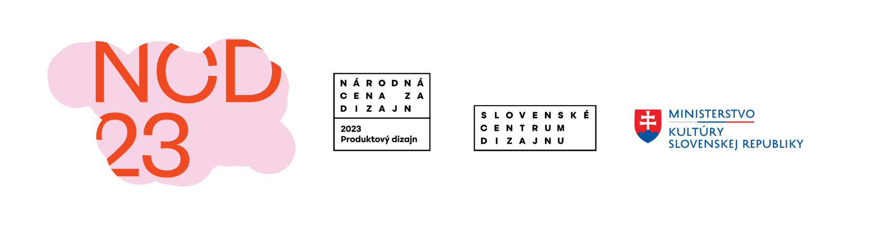
SLOVAK DESIGN AWARD 2023 EXHIBITION: COME HAVE A LOOK AT THE BEST SLOVAK PRODUCT DESIGN

NCD23
Press Release
Bratislava

Location: Pradiareň 1900, Svätoplukova 2A, 821 08 Bratislava
Open: Tuesday – Wednesday 10 a.m. – 6 p.m., Thursday – Sunday 1 p.m. – 6 p.m.
Duration: 27 September – 3 November 2023
Opening: 26 September 2023, 5 p.m.

The long-awaited Slovak Design Award 2023 exhibition is coming soon. The exhibition presenting the best Slovak product design from the past two years will open in the early evening on 26 September in the brand-new space of Pradiareň 1900.

The new exhibition space offers a larger area to present and interact with design. Each and every part of the exhibition was carefully designed by Peter Liška, exhibition architect, enabling spectators to enjoy a unique experience, to see and experience singular and diverse works, and innovative materials used in textile, interior, and transportation design. The exhibition includes works by established designers as well as student works, that push the boundaries of modern design.

“The arrangement of the Slovak Design Award 2023 – Product Design exhibition follows in the vein of the previous year’s exhibition of communication design. It is utilizing the same principle of translucent areas, this time predominantly in horizontal positions, serving as pedestals and light diffusers. On the one hand, it creates a structured environment, fulfilling various needs of exhibited objects. Simultaneously, the space remains airy and full of light,” said Peter Liška, NCD23 exhibition architect.

The Slovak Design Award 2023 exhibition will introduce 67 product design works including 25 nominations selected from a total of 195 registered works in 8 categories in early July by an international seven-member jury comprising Michal Staško (SK), Mária Račeková (SK), Stefan Moritsch (AR), Valerio Lupi Cherubini (IT), Václav Mlynář (CZ), Pavel Masopust (CZ), Jakub Berdych (CZ) with Tomáš Šetaffy (SK) as an external advisor.Má

The presentation of the short-listed works will be open from 26 September 2023 at 5 p.m. in Pradiareň 1900 and the winners will be announced on 9 October 2023 at the award ceremony at the Nová scéna theatre.

Curator: Michal Staško
Graphic design: Aurélia Garová, Tereza Maco, Jozef Sklenka
Exhibition architecture: Peter Liška

List of main exhibiting authors:

Augustínová Šošková Nina — Brnáková Juliána — Brunčáková Kristína — Capík Pavol — Cehlárik Damián — Čopíková Mia — Danko Adam — Diasníková Karolína — Dráb Martin — Ďurikovič Martina — Dzurenda Štefan — Filan Halásová Katarína — Galanský Šimon — Golianová Natália — Hudec Adam — Hudečková Martina — Hulala Andrej — Chrastinová Pojezdálová Andrea — Jánoš Ján — Karpiš Alojz — Kasanová Zuzana — Kepová Tímea — Kovaříková Ester — Kožička Šimon — Krampla Filip — Krnáč Lukáš — Krupanová Adriana — Kubušová Vlasta — Lagin Matúš — Machata Peter — Manduľák Dušan — Marek Dalibor — Marjak Peter — Matejková Karolína — Matušková Naďa — Maukš Filip — Melichárek Miloslav — Míček Bystrík — Mogas Soldevila Laia — Muchová Veronika — Olejár Juraj — Ontkóc Ľubomír — Palušová Ivana — Paulová Diana — Polgáryová Eva — Pollág Jakub — Rabada Matej — Rabadová Veronika — Riabič Michal — Ružinský Tomáš — Serbák Zuzana — Somarakis Georgios — Sršňová Lenka — Straka Juraj — Štalmach Michal — Štefániková Nina — Štraneková Mária — Tomulcová Monika — Tóth František — Tóth Zoltán — Tvarůžek Martin — Vicianová Petra — Viktor Tabiš — Vlasova Inna — Vlčková Jana — Vonkomerová Andrea — Zafka Mário — Žiková Ľudmila

List of studios and companies:

Ateliér Hora — crafting plastics! studio — DumoLab Research — Essential Antwerp — KARPIŠ — Krošlák — LEEDA — MADbyMAD — MUSA — PASEQ WOODWORKS — Patak motors — SHARVAN Bike — TEXTILE STUDIO JD — Tuli — WERKEMOTION — Woetive — zeitgeist.limited

For more information visit https://scd.sk/ncd or our social media – Slovak Design Award's IG and FB, Slovak Design Center's IG and FB.

#scd #ncd #ncd2023 #dizajn #design #slovakdesignaward #narodnacenazadizajn

Competition announcers:
Ministry of Culture of the Slovak Republic, Slovak Design Center
Organizer: Slovak Design Center
SCD's general advertising partner:
J&T Banka
SCD's main partner:
Antalis
SCD's main media partner:
Designum
NCD's general media partner:
RTVS
NCD’s main partners:
Nová scéna theatre, Repairably, Slovak Fashion Council
NCD’s product partners:
Budiš
Ultra Premium Brands, exclusive distributor of Campari premium brand in Slovakia
Exhibition’s main partner:
Pradiareň 1900
Partner for accompanying events:
Hemisféra ľavá o.z., Kino Lumière, Slovenská národná galéria

NCD’s media partners
Aktuality.sk
Archinfo
Čerstvé ovocie
Denník N
DeTePe
Dobré noviny
In-ba
Interez
Protisedi.cz
Rádio FM
Refresher

DATES
27 September – 3 November 2023: NCD23 exhibition
9 October 2023: Award Ceremony

ORGANIZATION TEAM
Zuzana Böhmerová
NCD 2023 coordinator
zuzana.bohmerova@scd.sk
+421 918 110 248

Maroš Schmidt
director of SCD, expert cooperation
maros.schmidt@scd.sk

Michal Staško
NCD 2023 curator
michal@stasko.sk

Gabriela Rybáriková
exhibition production and programmes for the public
gabriela.rybarikova@scd.sk
+421 918 110 247

Silvia Kružliaková
head of SMD, expert cooperation
silvia.kruzliakova@scd.sk

Barbora Káňová
PR and contact for media
barbora.kanova@scd.sk
+421 915 697 581

Aurélia Garová, Tereza Maco, Jozef Sklenka
visuals and graphic design for NCD 2023
garova.aurelia@gmail.com, terezasufliarska@gmail.com, jozef@sklenka.sk

Peter Liška
NCD23 exhibition architect
atelier@peterliska.sk

